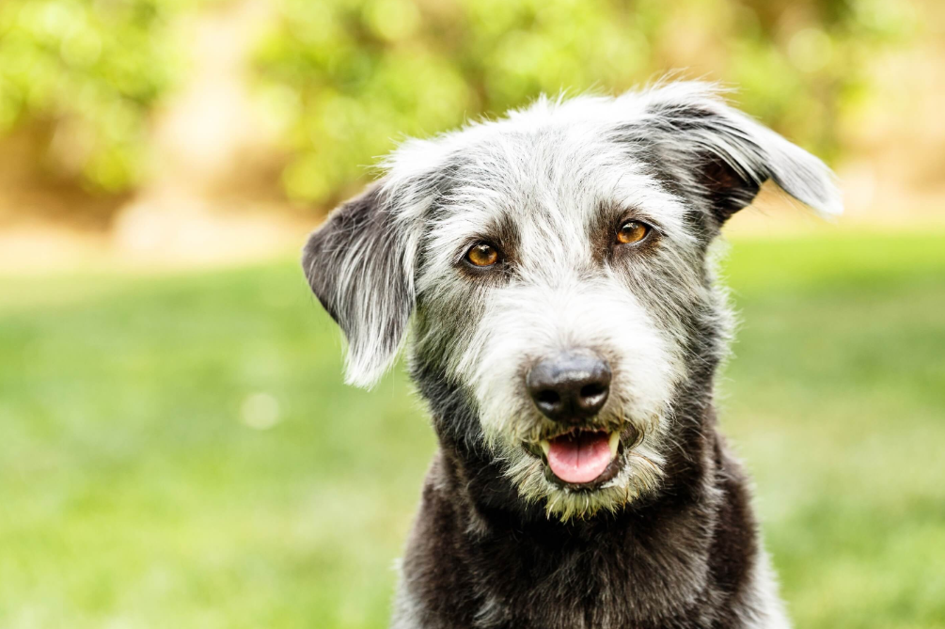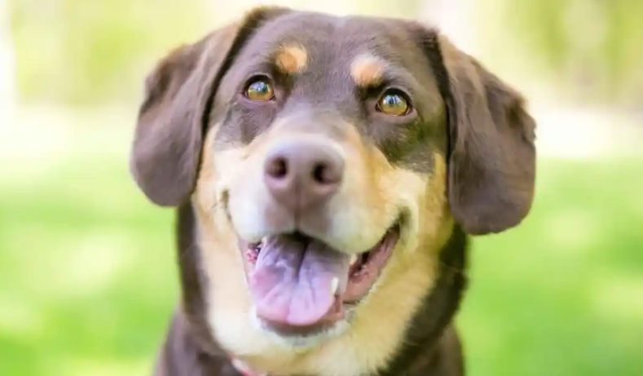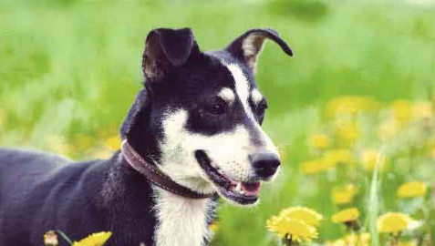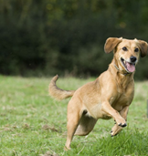
COMMUNITY
DOG SHOW

Sun 12th October 2025
Supported by LGMCIC and North West Kent Dog Training Club
Leybourne Chase Community Centre

11.00am to 4.00pm


Prizes, Rosettes and Certificates
Pet stalls
Cutest Puppy – Best Veteran
Waggiest Tail – Best Long Haired – Best Short Haired
Best Rescue Dog
This is a Fun show, where only dog handlers who have NOT entered in a Kennel Club Open or Championship show are eligible to take part.
For more details and registration, please email: Len@leybournechase.org

