Macmillan Coffee Morning & Teddy Bears Picnic raises £500 for Macmillan Cancer Support
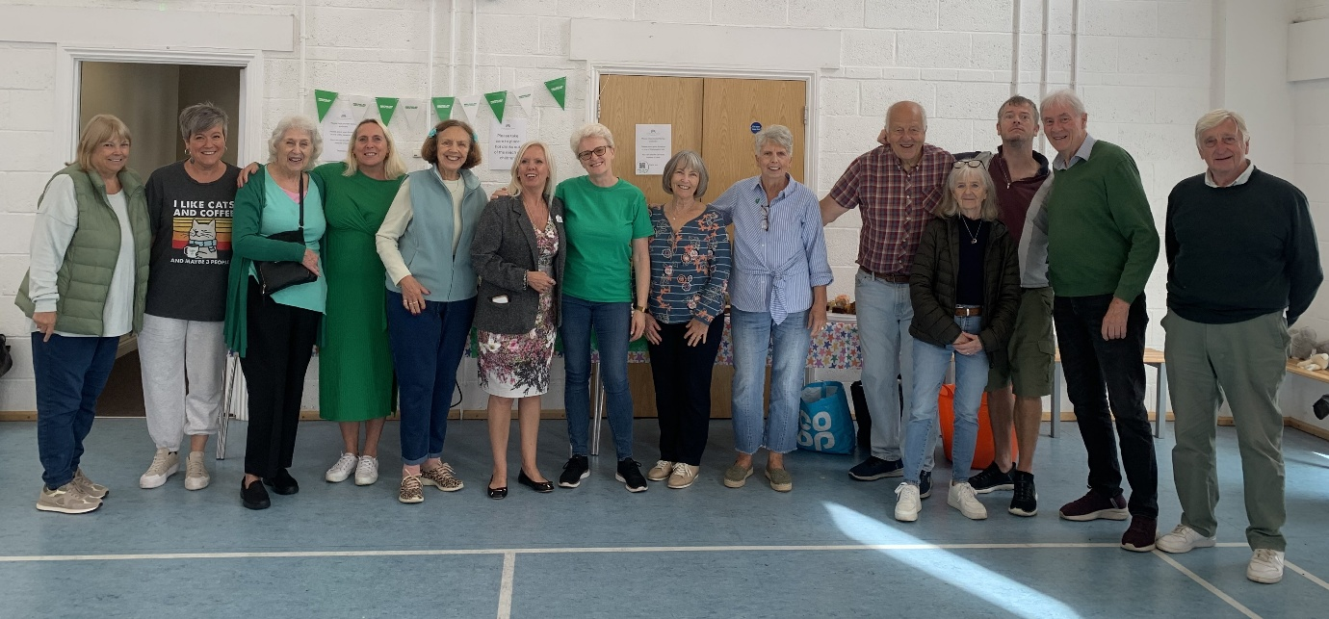

We are really pleased to announce that last Friday’s coffee morning and teddy bears picnic has raised £500.30 for Macmillan Cancer Support. The event was organised by Bonnie White and the 50+ Club with help and support from all of the following organisations who paid for the activities, donated raffle prizes and generously gave up hours of their time:
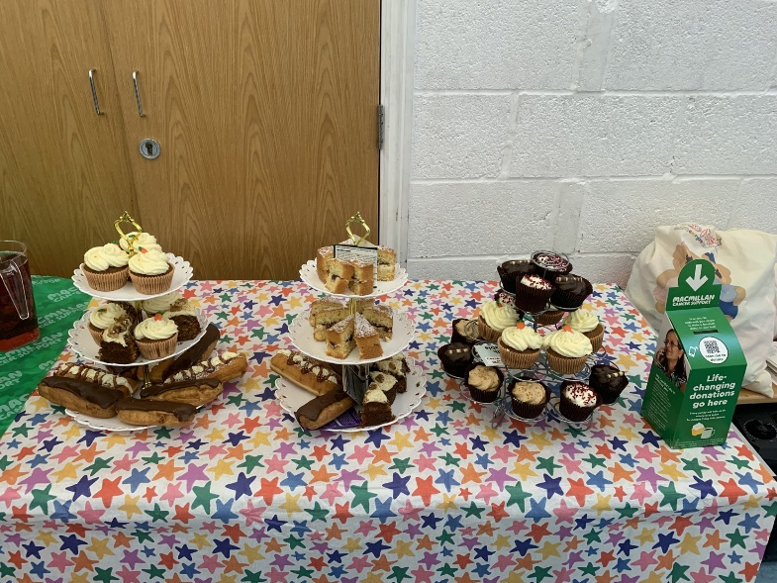
- Leybourne Parish Council
- GHCS, construction consultants
- Average Doughs
- Bulunga Coffee Bar
- Skinco Beauty Studio
- Hair Styled by Danielle
- Asda
- Tesco
- Vivian Corke
- Rachel Fuller
- Bonnie White Tuition
- Excel Tutoring
- Heroes Performing Arts
- Lily Webb School of Dance
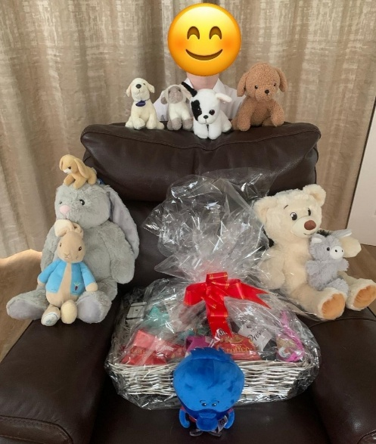
- Baby Ballet
- Hartbeeps
- Musical Bumps
- Fit Mum Squad
- The Arts Society
- Malcolm and his woodwork buddies
- The 50+ Club
- Other individual members of the community
- Leybourne Grange Management CIC
The morning was an amazing success with all ages really enjoying the activities on offer, the cakes and most importantly the conversation!
Thank you to everyone who came along and who donated to this amazing good cause.

